|  |  |  |  |  |  |
| --- | --- | --- | --- | --- | --- |
| **Test Name** | | Reported Bug 2 of Hotel Reservation System Test 1.1 | | | |
| **Use Case Tested:** | | Record Service | | | |
| **Test Description:** | | This test was performed to demonstrate the buggy behavior of the reported second bug of Hotel Reservation System. First of all user check out from the room. After that user tries to record a service again for the same room. System allows the user to the record a service for the same room after user check out from that particular room. | | | |
| **Pre-conditions** | | * The main menu of Hotel Reservation System is displayed to the user. | | | |
| **Post-conditions** | | 1. Normal flow and alternative flows where a record of service is successful.  * The service charge is inserted to the booking. * The service charge will appear on the checkout invoice.  1. All other unsuccessful scenarios  * No change to anything. | | | |
| **Result (Pass/Fail/Warning/Incomplete)** | | **Passed** | | | |
|  | **TEST STEP** | | **EXPECTED TEST RESULTS** | **P** | **F** |
| **Test Steps of User Check Out from Hotel Reservation System** | | | | | |
|  | User enters Room Number | | System displays final invoice to the user. |  |  |
| Then display prompt to accept the charges. |  |
|  | User accepts the charges | | System displays the prompt to select and enter Credit Card Type. |  |  |
|  | User enters selected Credit Card Type | | System displays the prompt to enter Credit Card Number. |  |  |
|  | User enters selected Credit Card Number | | System displays the prompt to enter Credit Card CCV Number. |  |  |
|  | User enters selected Credit Card CCV Number | | System displays checkout debit message to the user. |  |  |
| **Test Steps of Record Service after User Check out from Hotel Reservation System** | | | | | |
|  | User enters Room Number which was check Out by the User. | | Display the prompt to select the Service Type to the user. |  |  |
|  | User enters the selected Service Type | | Display the prompt to show the cost to the user. |  |  |
|  | User enters the cost | | Display the Service Charge Cost Confirmation to the user. |  |  |
|  | If the user entered Room Number not found | | Display “No active booking found “error message to the user. |  |  |
|  | If the user entered null inputs for the Room Number or for the Service Type | | Display cancelled message to the user. |  |  |

* **Hotel Reservation System allows user to record a service for the room after user check out from the Hotel Reservation System. But system should not allow the user to record a service for the room number after user check out from that particular room. Therefore there is a bug in the Hotel Reservation System even these test steps were passed.**

|  |  |  |  |  |  |  |
| --- | --- | --- | --- | --- | --- | --- |
| **Test Data Table** | | | | | | |
| **Data Field Name** | **1** | **2** | **3** | **4** | **5** | **6** |
| Room Number | 101 | 201 | 301 | 110(This Room Number doesn’t exists) | Null | 401 |
| Service Type | ROOM_SERVICE | BAR_FRIDGE | RESTAURENT | ROOM_SERVICE | RESTAURENT | Null |
| Cost | $200 | $100 | $150 | $200 | $150 | 0 |

* **Output of the buggy behavior of Reported Second Bug:-**

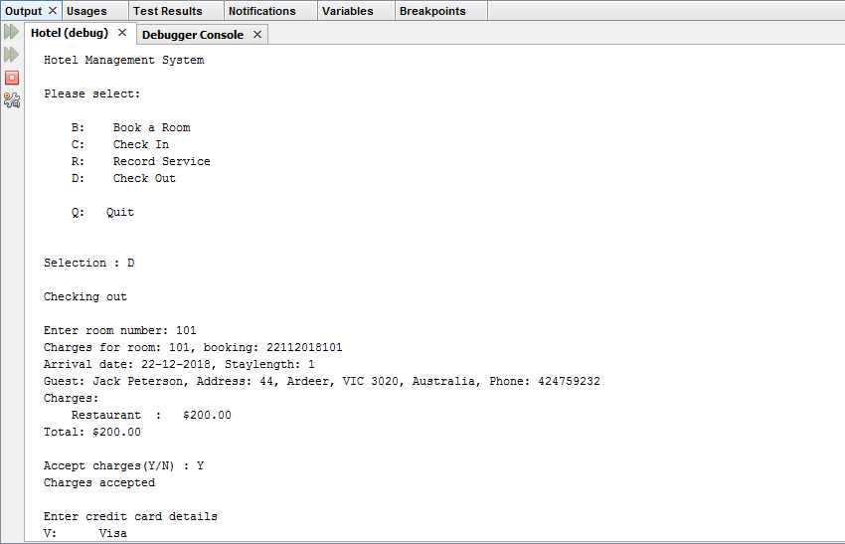

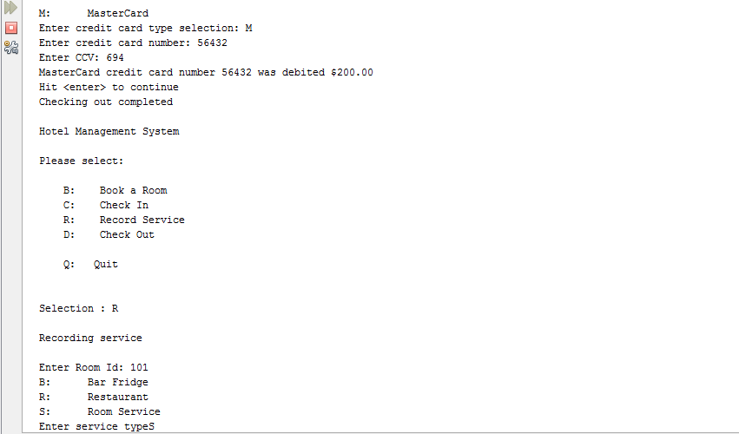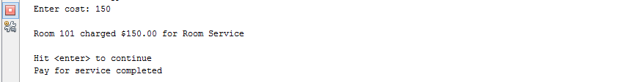

## ***Figure 1***